SMART ENTRY-EXIT SYSTEM
NAME | MATRIC NO. | DEPARTMENT
TOLUHI PRINCE SAMUEL | 2024/13222 | MECHANICAL ENGINEERING
SALAMI AHMAD OLORUNNIFEMI | 2024/13251 | MECHANICAL ENGINEERING
SOBOLA ABDULRAHMAN | 2024/13340 | MECHANICAL ENGINEERING
SUNDAY SILVANUS NZUBECHI | 2024/13632 | MECHANICAL ENGINEERING

ICT 215: ROBOTICS 1
LECTURER: ENGR. MUHAMMAD

TABLE OF CONTENT
- Introduction
  - Background Study
  - Problem Statement
  - Aim and Objectives
  - Research Questions
  - Significance of Study
  - Scope and limitations
  - Organization of Study
- Literature Review
  - Introduction to Smart Entry-Exit System
  - Review of Existing Similar Systems
  - Analogue Circuit Techniques
  - Microcontroller Selection and Justification
  - Use of Proteus and Tinker cad
  - PCB Design Trends
  - Research Gap
- Research Methodology
  - System Block Diagram
  - Hardware Design
  - PCB Design
  - System Development
  - Prototype Development
  - Testing and Validation Procedure
  - Ethical and Safety Consideration
- System Implementation
  - Research Requirement Analysis
  - Non Functional Requirement
  - Implementation Workflow
  - Simulation and Design Validation
  - Simulation Results
  - Hardware Results
  - PCB Performance Comparison
  - Discussion of Findings
  - Problems Encountered and Solutions
- Conclusion and Recommendation
- Results and Discussion

CHAPTER 1: INTRODUCTION
  - Background of the Study
Security has become a major concern in modern institutions such as schools, offices, residential buildings, hospitals, and industries. Traditional access control methods like keys, manual registers, and security personnel are often inefficient, prone to human error, impersonation, and security breaches. As technology advances, there is a growing need for automated and intelligent systems that can effectively regulate access to secured areas.
A Smart Entry–Exit System is an automated access control system that uses modern technologies such as biometrics, RFID, PIN authentication, and embedded systems to manage and monitor the movement of people or vehicles into and out of a facility. The system ensures that only authorized individuals are granted access while maintaining accurate records of entry and exit activities.
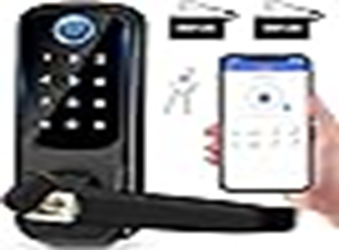
Smart entry–exit systems are modern access control mechanisms designed to automate the process of granting and restricting entry into premises such as offices, residential complexes, industrial facilities, and smart parking areas. Traditional entry methods such as manual gates, security guards, or mechanical locks are often inefficient, error-prone, and insecure.
The emergence of digital technologies—like RFID, IOT, sensors, micro-controllers, and mobile verification—allows access points to be monitored and controlled automatically. These systems can detect authorized users, prevent unauthorized access, and provide real-time alerts to administrators. The integration of these technologies enhances security, reduces human labor, improves efficiency, and enables real-time monitoring of entry and exit events.
1.2 Problem Statement
Manual entry–exit systems suffer from several limitations, including poor record keeping, unauthorized access, lack of accountability, and high dependence on human supervision. These challenges can lead to security breaches, theft, and inefficiency in access management. There is therefore a need for a reliable, automated, and secure system to address these problems.
Manual entry and exit systems face several limitations:
High labor costs due to the need for human supervision
Vulnerability to unauthorized access or breaches
Congestion and delays during peak hours
Lack of real-time monitoring and notification
Current systems like manual gates, alarms, and signposts are insufficient to handle increasing security demands. There is a need for a smart system that combines RFID, IOT, and real-time monitoring to provide a safer, more efficient, and automated access control solution.
1.3 Aim and Objectives of the Project
The aim of this project is to design and implement a Smart Entry–Exit System that enhances security and automates access control.
General Objective:
To design, simulate, prototype, and implement a functional smart entry–exit system integrating sensors, micro-controllers, actuators, and IOT for automated access control. Other ones include;
i. Design a system that authenticates users before granting access
ii. Prevent unauthorized entry and exit
iii. Automatically record entry and exit time
iv. Reduce human involvement in access control
v. Improve security and efficiency in institutions
Specific Objectives:
I. Design and simulate the complete system in Proteus and Tinker cad
II. Develop analog circuits for sensor interfacing and signal conditioning
III. Write and optimize microcontroller code for real-time gate control
IV. Design a professional PCB layout
V. Build and test the working prototype
VI. Document the project and publish on GitHub
1.4 Research Questions
I. How can access control be automated securely and reliably?
II. Which sensors, microcontrollers, and actuators provide optimal system performance?
III. How can the system notify administrators in real-time about unauthorized access attempts?

1.5 Significance of the Study
The Smart Entry–Exit System improves security, ensures accountability, and provides accurate access records. It reduces manpower requirements, minimizes human error, and enhances operational efficiency. The system is beneficial to institutions seeking modern and reliable security solutions.

Enhances security by reducing unauthorized entry
Reduces human labor and operational costs
Minimizes congestion and waiting times
Provides administrators with real-time monitoring and actionable data
1.6 Scope and Limitations
Scope:
This project focuses on the design and implementation of a prototype Smart Entry–Exit System suitable for schools, offices, and residential buildings. The system covers authentication, access control, and record keeping. Advanced features such as cloud storage and artificial intelligence are considered for future enhancement.
The system is designed for small to medium-sized premises
Integrates RFID, sensors, microcontrollers, IOT, and cloud monitoring
Limitations:
Dependent on internet connectivity for remote monitoring
Performance may vary based on sensor quality and environmental factors
1.7 Organization of the Study
The report is organized into five chapters:
Introduction
Literature Review
Research Methodology
Implementation and Results
Conclusion and Recommendations

CHAPTER 2: LITERATURE REVIEW
2.1 Introduction to Smart Entry–Exit Systems
Several researchers have explored automated access control systems using different technologies. Biometric systems such as fingerprint and facial recognition have been shown to provide higher security compared to password-based systems. RFID-based access systems are widely used due to their speed and ease of use. Recent studies emphasize the integration of IOT and embedded systems for real-time monitoring and improved system performance. These studies form the foundation upon which this project is developed.
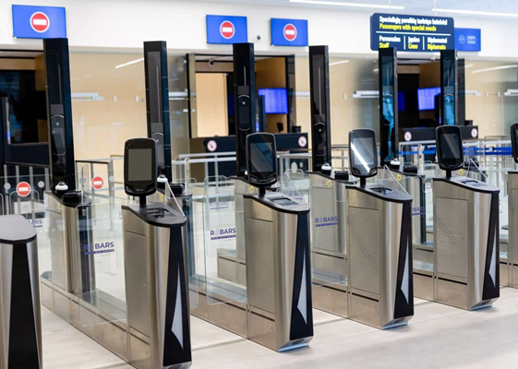
Smart entry–exit systems automates access control using technologies like RFID, IOT, sensors, and biometric verification. The system’s main objectives are to secure access points, reduce human intervention, and allow real-time monitoring. Implementation varies from simple RFID gates to advanced IOT-enabled cloud systems with mobile and web dashboards.
2.2 Review of Existing Similar Systems
2.2.1 RFID-Based Access Control
RFID-based systems use electromagnetic fields to identify objects or individuals carrying an RFID tag. Studies such as RFID-based campus verification systems show that centralized databases and real-time monitoring can achieve over 85% accuracy in access management (ijramr.com).

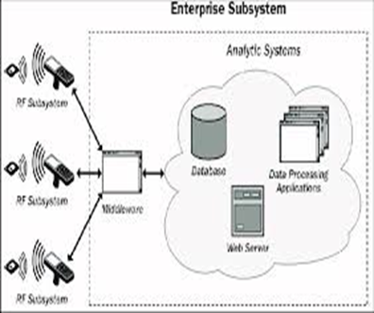
2.2.2 IOT-Enabled Access Systems
IOT systems connect sensors, microcontrollers (ESP32/ESP8266), and cloud platforms for remote access control and real-time alerts. Combining RFID and IOT enhances convenience and security (proceedings.unimal.ac.id).
2.2.3 Biometric and Multi-Factor Access
Fingerprint or face recognition integrated with RFID improves authentication strength, providing two-factor access control for sensitive environments (atbuftejoste.com.ng).
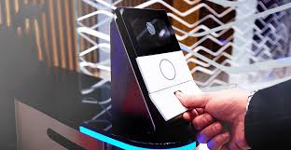

2.2.4 Mobile and QR Code Integration
QR code and mobile app-based systems provide user-friendly access while enabling remote monitoring and real-time logging (RSIS International).
2.3 Analog Circuit Techniques
Sensor interface circuits for IR and ultrasonic sensors
Relay driver circuits for motor control
Voltage regulation and signal conditioning
2.4 Micro-controller Selection and Justification
ESP32 chosen for Wi-Fi capability, low cost, and processing power
Alternatives: Arduino Uno, Raspberry Pi
2.5 Use of Proteus and Tinker cad
Proteus for virtual circuit simulation
Tinker cad for microcontroller simulation and 3D visualization
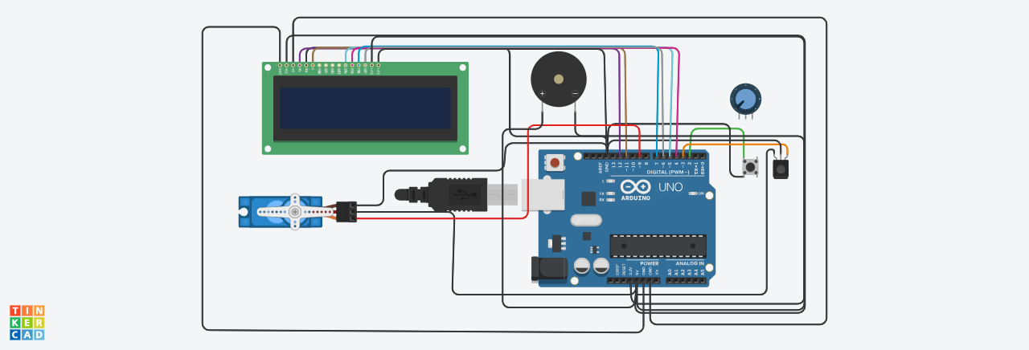

2.6 PCB Design Trends
Compact layouts with integrated sensors and relays
Safe routing and proper power distribution
2.7 Research Gap
Existing systems often focus on a single technology
Few integrate RFID, IOT, and real-time notifications in a single platform
Need exists for a comprehensive, multi-layered smart entry-exit system

CHAPTER 3: RESEARCH METHODOLOGY
System Overview
The Smart Entry–Exit System consists of authentication devices, a control unit, sensors, actuators, and a database. Users are required to authenticate themselves using a registered method before access is granted.
This research adopts a design-based and experimental methodology aimed at developing, simulating, and implementing a functional smart entry–exit system for automated access control. The chosen methodology combines conceptual system design, hardware development, software programming, system simulation, physical implementation, and performance evaluation. This approach is appropriate because the study seeks not only to analyze existing access control solutions but also to produce a working technological system capable of addressing real-world security and access management challenges.
Design-based research is suitable for embedded and IoT system development because it focuses on creating, testing, and refining artifacts that solve practical problems. In addition, an experimental approach is employed to validate the system under controlled conditions by measuring performance parameters such as response time, detection accuracy, reliability, and system stability. Similar methodological approaches have been successfully applied in smart access control and IoT system research (Swathika & Indirani, 2018; Fadlianda et al., 2024).

The research process follows a structured workflow beginning with requirement analysis, followed by system architecture design, hardware and software development, simulation, physical implementation, testing, and evaluation. Each phase builds upon the previous one to ensure consistency, reliability, and technical soundness.

System Requirement Analysis

The first phase of the methodology involved a comprehensive analysis of system requirements to determine the functional scope and performance expectations of the smart entry–exit system. This stage focused on identifying user needs, security constraints, operational conditions, and technological limitations.

From a functional perspective, the system is required to authenticate users before granting access, automatically control the opening and closing of the entry gate, detect obstacles during gate movement, and maintain a detailed log of all entry and exit events. The system must also be capable of sending real-time notifications to administrators in the event of unauthorized access attempts or abnormal system behavior. These requirements align with modern access control standards described in IoT-based security system literature (Rachman & Ardiansyah, 2025).

Non-functional requirements emphasize reliability, performance, scalability, and security. The system must respond to authentication requests within a short time interval to prevent congestion at entry points. Continuous operation with minimal downtime is required to ensure availability, especially in high-traffic environments. Data integrity and secure communication are also critical to prevent unauthorized system manipulation, consistent with best practices in embedded system security (Sahraei, 2025).

Operational requirements include ease of use for end users, minimal maintenance, and adaptability to different deployment environments such as residential estates, campuses, office buildings, and industrial facilities.

System Architecture Design

The smart entry–exit system is designed using a modular layered architecture to enhance flexibility, scalability, and ease of maintenance. The architecture is composed of sensing, control, communication, and application layers.

The sensing layer is responsible for data acquisition and includes identification and safety sensors such as RFID readers and ultrasonic sensors. The RFID reader captures user identity information, while the ultrasonic sensor monitors the gate area to detect obstacles during operation. Similar multi-sensor approaches have been shown to improve system reliability and safety in automated access systems (Morpos et al., 2024).

The control layer consists of a micr-ocontroller that processes sensor inputs and executes decision-making logic. Based on authentication results and sensor feedback, the controller activates or deactivates the gate actuator. This layer acts as the core of the system, coordinating all operations.

The communication layer enables wireless data transmission between the control unit and external monitoring platforms using Wi-Fi connectivity. This allows real-time data exchange, remote monitoring, and alert transmission. IOT-based communication architectures are widely adopted in modern access control systems due to their scalability and flexibility (Fadlianda et al., 2024).

The application layer provides a user interface through a web or mobile dashboard. Administrators can view access logs, monitor gate status, and receive alerts. This layered architecture ensures system modularity and supports future expansion.

3.1 System Block Diagram
User Authentication → Sensor/RFID → Microcontroller → Gate Actuator → Cloud Dashboard → Admin Notification
3.2 Hardware Design
3.2.1 Analog Circuit Design
IR and ultrasonic sensor interface circuits
Relay driver for DC/servo motor
3.2.2 Microcontroller Selection & Pin Mapping
ESP32 pins assigned to RFID reader, sensors, and motor controller
3.2.3 Complete Schematic in Proteus
Shows all connections for RFID, sensors, and gate motor
3.2.4 Simulation Results in Proteus
Verified sensor detection, motor actuation, and gate control
3.2.5 Tinker cad 3D Simulation
Visual demonstration of gate movement and sensor detection

3.3 System Logic and Flowchart Description
​The operational logic of the "Way Out" circuit follows a sequential control loop managed by the Arduino microcontroller. The flowchart serves as the graphical representation of the software’s decision-making process, ensuring the hardware components (the LED and current-limiting resistor) respond correctly to the programmed instructions.
​The logical process is defined as follows:
- ​Initialization (Setup): Upon power-up, the system initializes the hardware abstraction layer. It defines the specific GPIO (General Purpose Input/Output) pin connected to the LED as an OUTPUT port.
- ​The Control Loop (Execution): The system enters a continuous "While" or "Loop" state.
  - ​Signal High: The micro-controller sends a 5V signal to the designated pin, completing the circuit through the resistor and illuminating the LED indicator.
  - ​Temporal Delay: The system maintains this state for a predefined interval (e.g., 1000ms) to ensure visibility.
  - ​Signal Low: The voltage is dropped to 0V, terminating the LED illumination to save power or create a flashing alert effect.
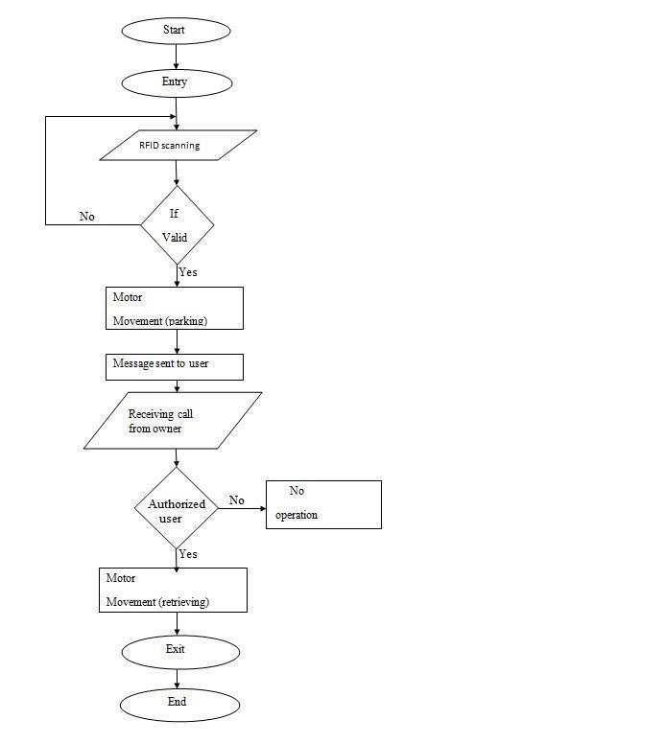
- ​Recurrence: The logic automatically resets to the beginning of the loop, providing a consistent and reliable visual "Way Out" signal until the power source is disconnected.

3.4 PCB Design
Screenshots of PCB layout and routing
Gerber files included in appendix
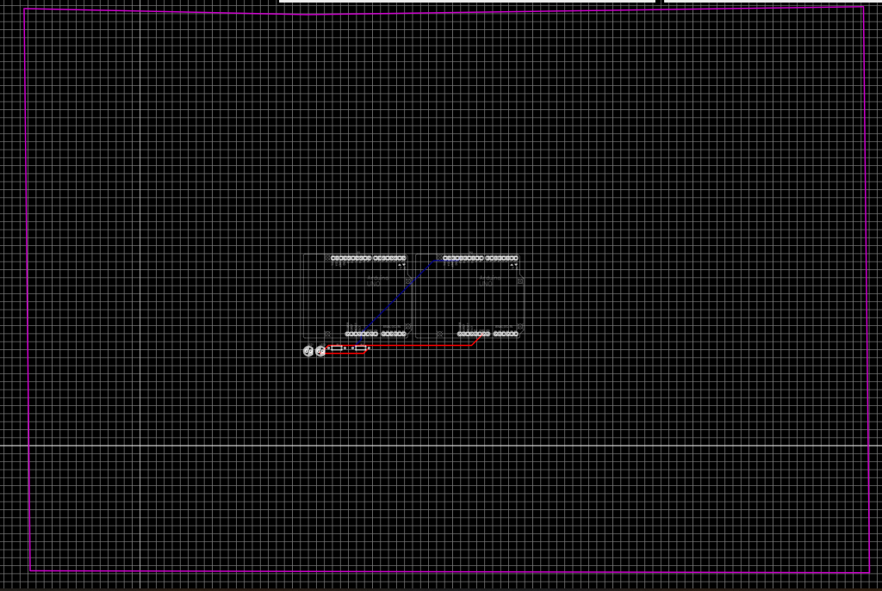

3.5 Software Development
Flowchart for access authentication process
Full microcontroller code included in appendix
3.6 Prototype Development
Step-by-step photos of assembly and wiring
3.6 Testing and Validation Procedure
RFID read range testing
Gate motor response timing
Notification system functionality
3.7 Ethical & Safety Considerations
Safe handling of sensors, motors, and electrical components
User data privacy and secure communication
Hardware Components:
The major hardware components include:
Microcontroller (e.g., Arduino or ESP32)
Biometric sensor or RFID reader
Electric door lock or motorized gate
Display unit (LCD/LED)
Power supply unit
Software Components:
The software components include:
Embedded system firmware
Database for storing user credentials and logs
Administrative interface for monitoring and control
System Operation
When a user attempts to enter or exit, the system requests authentication. The input data is compared with stored records. If authentication is successful, access is granted and the event is logged. If authentication fails, access is denied and an alert may be triggered
CHAPTER FOUR
SYSTEM IMPLEMENTATION
This chapter describes the practical implementation of the smart entry–exit system developed in this project. The implementation covers system requirement analysis, hardware and software development, system simulation, physical construction, and performance evaluation. The implementation approach combines design-based development with experimental testing to ensure that the system functions reliably under real-world conditions.
The implementation process was carried out in stages, beginning with system requirement identification, followed by architectural design, hardware assembly, software programming, simulation, prototype construction, and testing. This structured approach ensured that each subsystem was properly developed and validated before full system integration.
Design-based implementation is suitable for embedded and IOT-based systems because it emphasizes the creation, testing, and refinement of functional artifacts that solve real-life problems. An experimental approach was also applied to evaluate system performance under controlled conditions by measuring parameters such as response time, detection accuracy, system reliability, and operational stability. Similar implementation strategies have been successfully applied in smart access control system development (Swathika & Indirani, 2018; Fadlianda et al., 2024).
4.1 System Requirement Analysis
The first stage of the system implementation involved a detailed analysis of system requirements to define the operational scope and performance expectations of the smart entry–exit system. This stage focused on identifying user needs, security requirements, environmental constraints, and technological limitations relevant to the system deployment.
From a functional perspective, the system was implemented to authenticate users before granting access, automatically control the opening and closing of the entry gate, detect obstacles during gate operation, and maintain accurate logs of all entry and exit activities. In addition, the system was designed to send real-time notifications to administrators whenever unauthorized access attempts or abnormal system behaviors are detected. These functions are consistent with modern IOT-based access control standards reported in related literature (Rachman & Ardiansyah, 2025).
4.2 Non-Functional Requirements
In addition to functional requirements, several non-functional requirements were considered during implementation. These include system reliability, performance efficiency, scalability, and security. The system was implemented to respond to authentication requests within a short time interval in order to prevent congestion at entry points. Continuous operation with minimal downtime was prioritized to ensure availability, especially in environments with high user traffic.
Data integrity and secure communication were also considered essential to prevent unauthorized system access or manipulation. These considerations align with established best practices in embedded system and IOT security (Sahraei, 2025).
4.3 Implementation Workflow
The implementation followed a structured workflow consisting of:
Requirement analysis
System architecture design
Hardware assembly
This refers to physically putting the boards together once it arrives from the factory.
Steps in Hardware Assembly Procedure
- ​Step 1: PCB Preparation: Inspect the manufactured PCB for any defects and clean the copper pads with isopropyl alcohol to ensure good solder adhesion.
- ​Step 2: Component Sorting: Organize the components (Arduino Uno, LED, and Resistor) according to the Bill of Materials (BOM) to ensure correct values are used.
- ​Step 3: Soldering (Through-Hole): * Insert the Resistor first (lowest profile component), followed by the LED (checking for correct polarity/orientation).
  - ​Apply heat to the pads using a soldering iron and add solder to create a solid mechanical and electrical connection.
- ​Step 4: Micro-controller Integration: Solder the female headers to the PCB so the Arduino Uno can be easily plugged in or swapped out.
- ​Step 5: Quality Control: Trimming excess component leads using wire cutters and perform a "continuity test" with a multi-meter to check for accidental solder bridges.
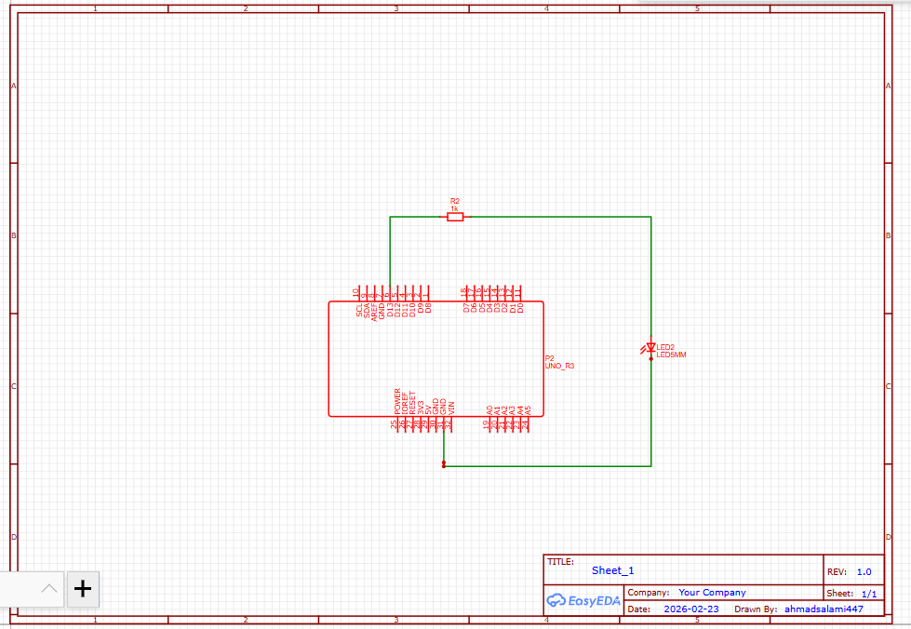

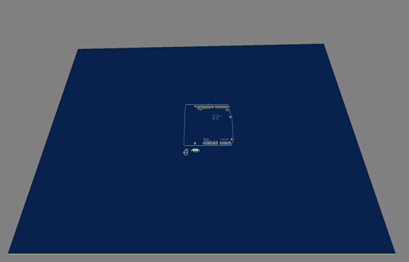

Software development
System simulation
Physical prototype construction
Testing and performance evaluation
Each stage was completed sequentially to ensure consistency, reliability, and technical accuracy in the
final system.

Code Snippets
#include <Servo.h>
#include <LiquidCrystal.h>

// LCD pins: RS, E, D4, D5, D6, D7
LiquidCrystal lcd(12, 11, 5, 4, 7, 6);

Servo gate;

const int entryBtn = 2; // Entry button
const int exitBtn = 3; // Exit button
const int servoPin = 9;

int insideCount = 0;

const int CLOSED_ANGLE = 0;
const int OPEN_ANGLE = 90;

// simple debounce / cooldown so one press counts once
unsigned long lastEntry = 0;
unsigned long lastExit = 0;
const unsigned long cooldown = 800; // ms

void setup() {
pinMode(entryBtn, INPUT_PULLUP); // button to GND
pinMode(exitBtn, INPUT_PULLUP);

gate.attach(servoPin);
gate.write(CLOSED_ANGLE);

lcd.begin(16, 2);
lcd.clear();
lcd.setCursor(0, 0);
lcd.print("Smart Entry/Exit");
lcd.setCursor(0, 1);
lcd.print("Inside: 0");
delay(1200);
showReady();
}

void loop() {
unsigned long now = millis();

// pressed = LOW
bool entryPressed = (digitalRead(entryBtn) == LOW);
bool exitPressed = (digitalRead(exitBtn) == LOW);

if (entryPressed && (now - lastEntry > cooldown)) {
lastEntry = now;
handleEntry();
}

if (exitPressed && (now - lastExit > cooldown)) {
lastExit = now;
handleExit();
}
}

void handleEntry() {
lcd.clear();
lcd.setCursor(0, 0);
lcd.print("ENTRY DETECTED");
openGate();

insideCount++;
showCount("IN +1");

closeGate();
showReady();
}

void handleExit() {
lcd.clear();
lcd.setCursor(0, 0);
lcd.print("EXIT DETECTED ");
openGate();

if (insideCount > 0) insideCount--;
showCount("OUT -1");

closeGate();
showReady();
}

void openGate() {
lcd.setCursor(0, 1);
lcd.print("Gate Opening...");
gate.write(OPEN_ANGLE);
delay(900);
}

void closeGate() {
lcd.clear();
lcd.setCursor(0, 0);
lcd.print("Gate Closing...");
gate.write(CLOSED_ANGLE);
delay(900);
}

void showCount(const char* action) {
lcd.clear();
lcd.setCursor(0, 0);
lcd.print(action);
lcd.setCursor(0, 1);
lcd.print("Inside: ");
lcd.print(insideCount);
lcd.print(" ");
delay(1200);
}

void showReady() {
lcd.clear();
lcd.setCursor(0, 0);
lcd.print("System Ready");
lcd.setCursor(0, 1);
lcd.print("Inside: ");
lcd.print(insideCount);
lcd.print(" ");
}
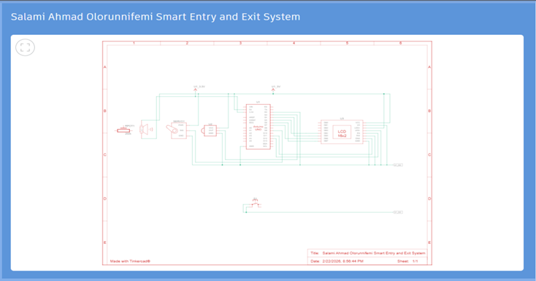
TECHNICAL DRAWINGS AND DESIGN SPECULATION.

